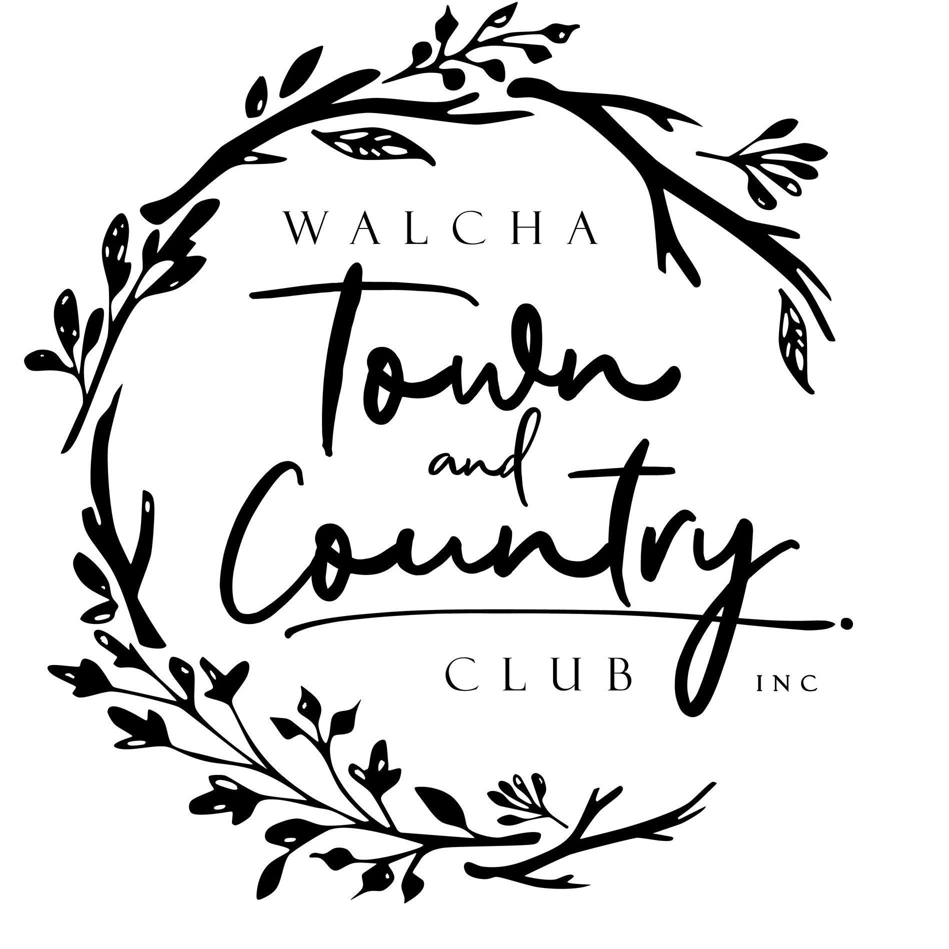

Annual Ladies Luncheon

Saturday 9 October 2021

Commencing 11:00 am
Hosted by Norm & Di Bazeley

“Elswick Park”

169 Aberbaldie Road
Walcha NSW 2354
Australia

SAVE THE DATE
Enjoy a Luncheon hosted in beautiful gardens at “Elswick Park” Walcha
More Information regarding ticket sales will be available closer to the date
This is a community fundraising event

